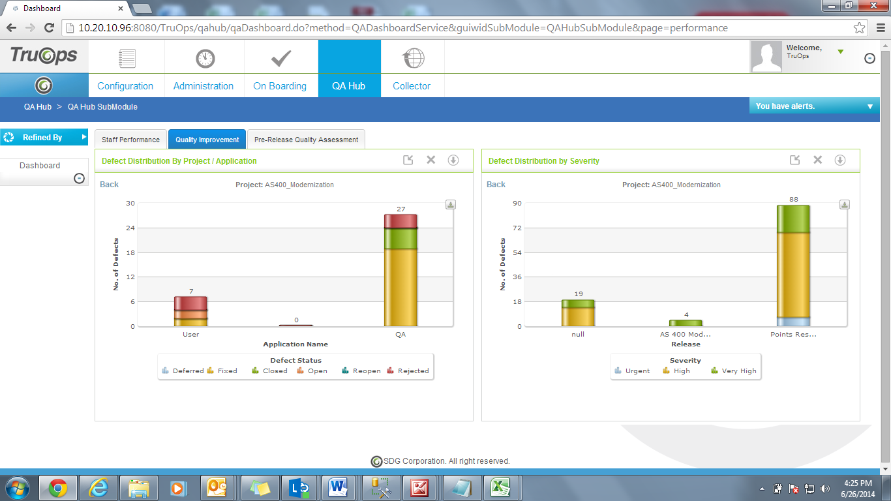

Wrong Application name.

Application Name missing

Instead of null it should be Unknown